**Project Design Phase-II**

|  |  |  |
| --- | --- | --- |
| **FR No.** | **Functional Requirement (Epic)** | **Sub Requirement (Story / Sub-Task)** |
| FR-1 | User Registration | Registration through Form |
| FR-2 | User Confirmation | Confirmation via EmailConfirmation via OTP |
| FR-3 | User QR code generation | QR code is generated |
| FR-4 | GPS tracker | Location is tracked |

**CUSTOMER JOURNEY MAP**

|  |  |  |  |
| --- | --- | --- | --- |
| **DATE** | | 17 SEPTEMBER 2022 | |
| **TEAM LEADER NAME** | | VISHNU M | |
| **TEAM MEMBERS** | | SOWMIYA R ,VENILLA AKSHAYA V,VIDHYASRI K V | |
| **PROJECT NAME** | | PROJECT – SMART SOLUTION FOR RAILWAYS | |
| **MAXIMUM MARKS** | | 2 MARKS | |
| **DATE** | | 18 October 2022 | |
| **PROJECT NAME** | | Project - Smart Solutions for Railways | |
| **MAXIMUM MARKS** | | 4 Marks | |

**CUSTOMER ENTRY AND EXIT MAP:**

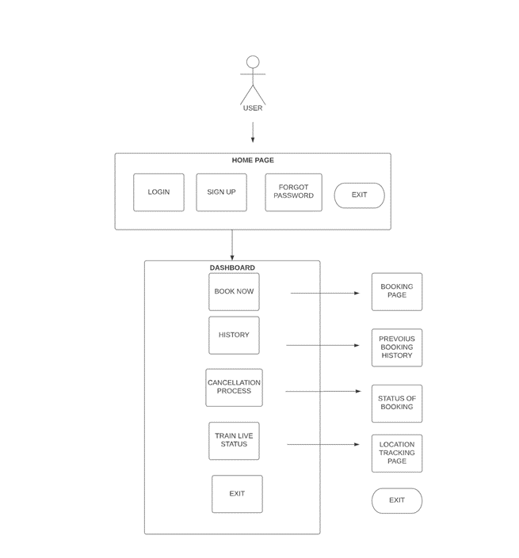

**DESCRIPTION:  
As a user, I can register for the application by entering my email address, password, and password confirmation.**

**Once I have registered for the application, I will receive a confirmation email.**

**As a user, I can sign up for the app using Facebook.**

**As a user, I can sign up for the application using Gmail.**

**As a user, I can access the application by entering my email address and password.**

**As a user, I can register for the application by entering my email address, password, and password confirmation.**

**Once I have registered for the application, I will receive a confirmation email.**

**As a user, I can sign up for the app using Facebook.**

**As a user, I can sign up for the application using Gmail.**